**Thevenin theorem using Proteus**

**LAB REPORT # 9**



**CIRCUIT ANALYSIS LAB**

Submitted by: **Afzal Ahmad**

Registration No: **24PWCSE2361** Class Section: **B**

Student Signature: ______________

Submitted to:

ENGR WASEEM KHAN

19,MAY 2025

Department of Computer Systems Engineering

University of Engineering and Technology, Peshawar

Contents

Objectives: 3

Thevenin theorem: 3

Schematic diagram:{Circuit 1} 3

Procedure: 4

Table: 7

Schematic Diagrams {Circuit 2}: 7

Observations And Calculation: 9

Conclusion: 9

# Objectives:

• To verify the Thevenin theorem on the simulation tool proteus

• To learn how to create and simulate the circuits in Proteus

# Thevenin theorem:

Any circuit containing several voltage sources and resistors can be simplified to a Thevenin equivalent circuit with a single voltage source and resistance connected in series

• Thevenin theorem is used to change a complicated circuit into a simple equivalent circuit consisting of a single voltage source, referred to as Thevenin voltage Vth in series with a single resistance, referred to as Thevenin Resistance Rth

# Schematic diagram:{Circuit 1}

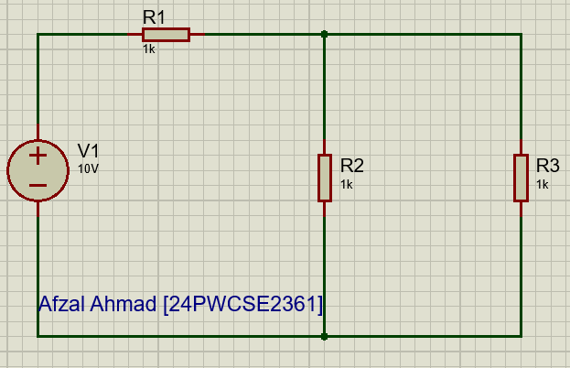

# Procedure:

* Make the circuit in Proteus
* Connect all pieces of equipment
* Connect a DC voltmeter in parallel with the one resistor
* Calculate the value of the voltmeter
* Now, short-circuit the resistor
* And calculate the voltage across the other close resistor
* Now make that voltage the value of the voltage source
* Now, calculate the equivalent resistance of the remaining resistors
* Now make a new circuit with the calculated voltage, the resistance, and the short circuit resistance

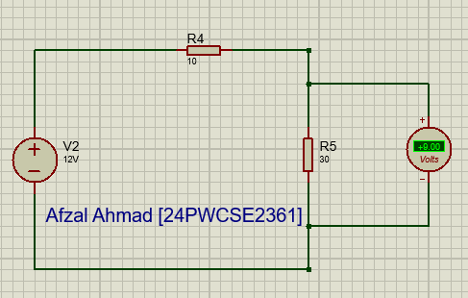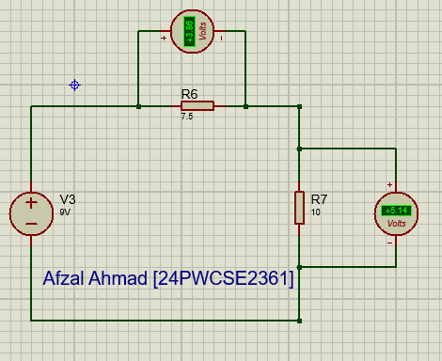

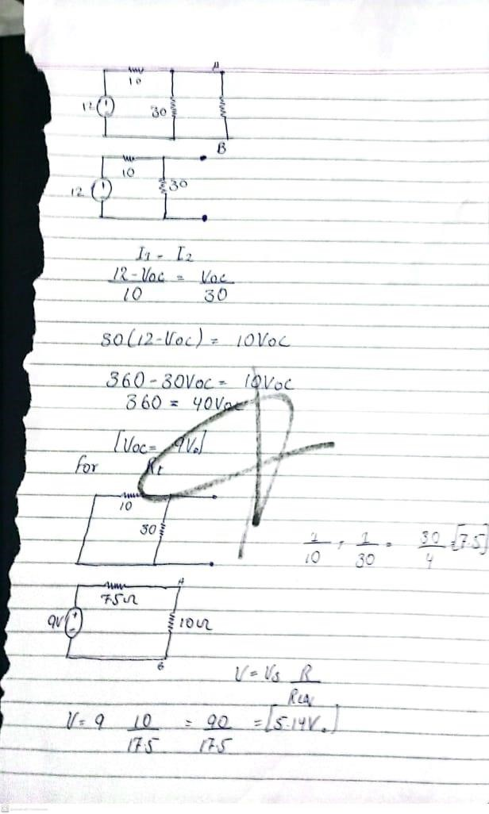

# Table:

|  |  |  |
| --- | --- | --- |
|  | using proteus | mathematical calculations |
| Voc | 9V | 9 |
| Rt | 7.5Ω | 7.5Ω |
| VAB | 5.14V | 5.14V |
| I | 0.51A | 0.51A |

# Schematic Diagrams {Circuit 2}:

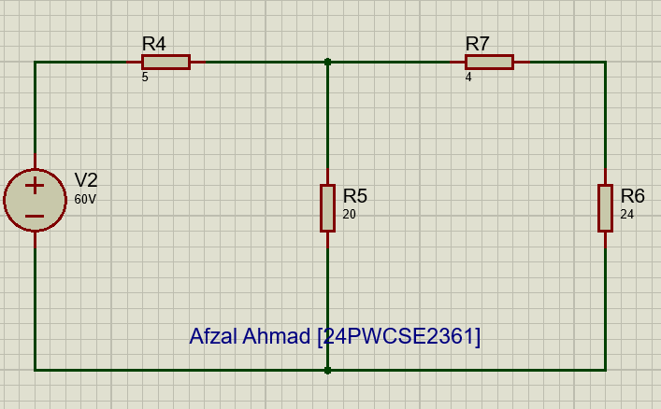

## Observations And Calculation:

|  |  |  |
| --- | --- | --- |
|  | using proteus | mathematical calculations |
| Voc | 48V | 48V |
| Rt | 8Ω | 8Ω |
| VAB | 36V | 36V |
| I | 1.5V | 1.5V |

# Conclusion:

The simulation in Proteus confirms Thevenin’s Theorem by showing that the voltage across the load resistor in the original circuit is equal to the voltage across the same load when connected to the Thevenin equivalent circuit. This validates that any linear network can be simplified to a single voltage

source and series resistance without changing the behavior at the load terminals.